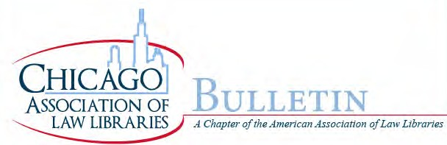

ISSUE 237- FALL 2015
President’s Letter, by Julie Pabarja…………………………………………………………………………………………….……………3
From the Editors, by Lyonette Louis-Jacques, Scott Vanderlin and Lindsey Carpino……………….……….…….…5
Meet New CALL Member LeighAnne Thompson, by Juanita Harrell…………………………………………………………6
Meet New CALL Member Stacia Stein, by Juanita Harrell………………………………………………………………….…….7
Meet New CALL Member Heather Hummons, by Jill Meyer…………………………………………………………….……..9

♦♦♦

LEEPing Into the Law Librarian Profession: a Glimpse Inside the University of Illinois LEEP Program “Boot Camp”, by LeighAnne Thompson………………………………………………………….……………………………………………….11
CALL Library School Experience, by Stacia Stein………………………………………………………………………………….…13

♦♦♦

AALL Annual Meeting and Conference 2015: A Newbie’s Journey, by Clanitra Stewart Nejdl………………..15
A New Librarian Goes to AALL, by Simone Srinivasan…………………………………………………………………………….18
Using Succession Planning and Knowledge Transfer to Connect the Generations, by JoAnn Hounshell…20
CALL Grantee Report, by Carolyn Hersch…………………………………………………………………………………………….…22
Keith Ann Stiverson, AALL President, by Lindsey Carpino……………………………………………………………………...25

♦♦♦

CALL Committee Roundup…………………………………………………………………………………………………………….………26
CALL Executive Board Minutes Summary, June 2015, by Diana Koppang………………………………………………29
CALL Leadership Orientation, by Julie Pabarja and Konya Lafferty…………………………………………………………30
What’s Buzzin’?, by Lindsey Carpino, Annie Mentkowski and Diana Koppang……………………………….………32
CALL Membership Survey Results, by Julie Pabarja………………………………………………………………………..………34
AALL2go Pick of the Month–Surveys: When to Use Them and Why, by Debbie Ginsberg………………………36

♦♦♦
Law Firm Librarian Current Awareness Resources, by Lindsey Carpino…………………………………………………36
2015 AALL Hackathon, by Trez Drake……………………………………………………………………………………………………38

♦♦♦

Summer Institute of the Association for Collaborative Leadership (CALL Grantee Report), by JoAnn Hounshell………………………………………………………………………………………………………………………………………………42

♦♦♦

MAALL 2015 Annual Meeting, by Lindsey Carpino…………………………………………………………………………………44
2016 AALL Local Arrangements Committee!, by Maribel Hilo Nash…………………………………….…………………45
AALL 2015 Conference Sessions Available on AALL2go, by Lindsey Carpino……………………………..……………46
AALL Business Skills Clinic, by Lindsey Carpino…………………………………………………………………………………….…47
CALL Meeting Schedule 2015-2016, by Julie Pabarja……………………………………………………………………………..48
About the CALL Bulletin …………………………………..……………………………………………………………………………………49

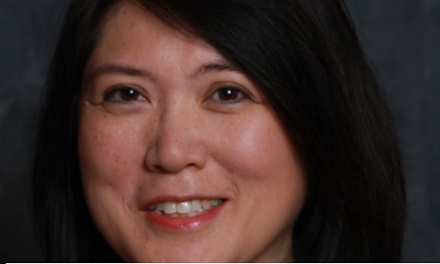

PRESIDENT’S LETTER
JULIE PABARJA
Dear CALL Colleagues,
It’s all about you! This year CALL will be about what the members need to keep up with the changes and challenges that our profession faces. It is important that we stay apprised of the latest trends and to have the skills to meet the demands of our job. CALL will also focus on helping develop our members into leaders who will not only lead in our institutions but also in our profession.

The member survey that was sent out this summer indicated that members want more education and networking events. The Board is collaborating with Committee Co-Chairs to provide more opportunities that members seek.

The Continuing Education Committee is busy planning programs on the latest issues. We introduced What’s Buzzin’? which is an informal gathering meant to engage discussions and share ideas. The first What’s Buzzin’? discussion was held this month with academic, law firm, and court librarians collaborating on what new attorneys need to know as they start their career. If you would like to suggest a topic to buzz about, send it me or another Board Member.

CALL wants to invest towards the success of our members. Don’t forget that CALL has grant monies available to use towards attending education events that will help enhance your skills.
CALL needs to look at the future of our profession and developing the leaders who will be leading our libraries and CALL.
The Mentoring and Leadership Development Committee has just launched the mentor program that will allow members to match themselves up with another member that they feel can help guide them down their career path. I encourage the more experienced members to consider being a mentor. This is not only a great opportunity to teach and guide our younger/newer colleagues, but also to learn from them. Our profession is constantly evolving and the mentoring program is a great way to develop a continuous learning conversation.

CALL will be reaching out to the library schools to let the students, especially the ones interested in law librarianship, know that we are here as a resource for them.
To communicate the latest trends and heighten awareness of CALL, the CALL Bulletin and the Public Relations committees are always promoting the fabulous things that our members do and featuring articles that educate us and highlight the value that librarians give to the legal world. If you are interested in social media, blog posting, or writing articles, I encourage you to investigate how you can contribute in these committees.
With the 2016 American Association of Law Libraries Annual Meeting and Conference coming to Chicago next July, there will be lots of opportunities to participate in showcasing our great city and collaborating with our colleagues who will be traveling here from all around the world. If you are not an AALL member, I recommend that you check out what their membership offers and consider attending the conference in July.

There is a lot of good stuff planned for CALL members this year. I am grateful for the commitment of the Board and Committee Co-Chairs. CALL is successful because of the members’ participation and the support that we give each other. I hope to build on that success and make sure that CALL continues to offer valuable opportunities to you. Do not hesitate to reach out to me if you have any suggestions or concerns.
It’s going to be a great year!
Julie

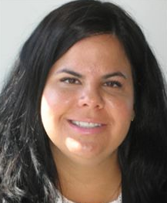

FROM THE EDITORS
LINDSEY ANN CARPINO, LYONETTE LOUIS-JACQUES, SCOTT VANDERLIN
Fall is officially here. It is time to cozy up with the Fall issue of the CALL Bulletin, while you enjoy your Pumpkin Spice Latte (made with real Pumpkin). This is a very exciting issue as we welcome new members to the Bulletin Committee and as regular columnists: Heather Hummons, Jill Meyer, Clanitra Stewart Nejdl, Stacia Stein, LeighAnne Thompson. Juanita Harrell will be writing a court librarian column. We also welcome Philip Johnson’s help with editing. And Annie Mentkowski as our Bulletin Historian.

Thank you all for your help with our award-winning publication! We look forward to a great year. We have many new perspective articles in this issue, from a few of our newer CALL members. LeighAnne Thompson and Stacia Stein share their “Bootcamp” experience in starting library school at the University of Illinois’ LEEP program. Clanitra Stewart Nejdl and Simone Srinivasan describe their first time attending the AALL Annual Meeting and Conference in Philadelphia. We also get to relive the conference through our CALL grantee report by Carolyn Hersch as well as Trez Drake’s report on the 2015 AALL Hackathon meeting.

We have a new column entitled “CALL Committee Roundup” which features regular brief updates from all of our committees. In this issue, each CALL committee shares its goals for the upcoming year. This will be a great way for all of us to stay informed on our chapter’s happenings!

Lindsey Carpino shares some of the professional current awareness resources she is using as a law firm librarian. We hear about what took place at the CALL Leadership Orientation held at DLA Piper in September. Julie Pabarja also shares with us the results from the CALL survey.

We fill you in on some of the AALL and MAALL professional development opportunities being offered in the near future. Mark your calendars
We hope you enjoy this issue!

MEET NEW CALL MEMBER LEIGHANNE THOMPSON
JUANITA HARRELL
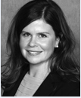
LeighAnne Thompson

JH: Tell us a little about yourself.
LT: I practiced ERISA law for 5 years. I just left Kirkland & Ellis at the end of June. I am the proud mother of a 2 ½ year old boy and a 10-month old girl.

JH: I know you are currently in the LEEP program at U of I. What classes are you currently taking or getting ready to take?
LT: I just started in July. I am currently taking Libraries, Information, and Society – an introductory course. I will be taking Reference, Instruction and Assistance; and Information Organization and Access in the fall.

JH: Why did you join CALL?
LT: I joined CALL about a week before this interview. I am also on the Bulletin Committee. It was recommended that I join CALL by fellow CALL member Lindsey Carpino and by other members of the profession.

JH: Are you currently working in a library setting?
LT: Not at this time but I will begin working as a reference associate at the law library at Northwestern in September.

JH: What brought you to librarianship? Law librarianship?
LT: I worked as a research assistant during law school and was on the editorial board of the law review. I worked closely with law librarians in those capacities. I liked the law and also had an interest in doing research.

JH: Are you a part of any other organizations? ALA, SLA, ILA, AALL, etc…
LT: I am also a member of AALL.

JH: What are your hobbies?
LT: Running, reading, and gardening. I really want to start traveling again.

JH: What book are you currently reading? Do you have a favorite author?
LT: I’m always reading three books at a time because sometimes I can read print, but other times I need to use the Kindle. I’m currently re-reading To Kill a Mocking Bird so that I can then read Go Set a Watchman. I am also reading Sarah Dessen’s Saint Anything and 1-2-3 Magic on child discipline. My favorite author is C.S. Lewis.

JH: Is there one book you could read over and over again.
LT: No, not at the time.

JH: Are you a coffee person, tea person, both or neither?
LT: Coffee. I am originally from Seattle and miss all of the local roasters and independent coffee shops.

MEET NEW CALL MEMBER STACIA STEIN
JUANITA HARRELL

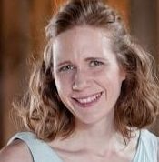
Stacia Stein

New CALL member, Stacia Stein, is a graduate student in the Graduate School of Library and Information Science (GSLIS) at the University of Illinois at Urbana-Champaign, and a member of the CALL Bulletin Committee.

Fellow Bulletin Committee member, Juanita Harrell, recently interviewed her so we could all get to know her a little better.

JH: Tell us a little about yourself.
SS: I went to DePaul for undergrad. I received my law degree in 2006. I studied German/ international studies, human issues. I also studied abroad in England and Ireland.

JH: I know you are currently in the LEEP program at University of Illinois. What classes are you currently taking or getting ready to take?
SS: I took a Law Librarianship class over the summer. I’m going to do a practicum at Northwestern in the fall and will also take Middle East Librarianship in the fall.

JH: Why did you join CALL?
SS: I joined about a year ago. I was recommended to join by a law librarian. I am also a member of the Bulletin Committee.

JH: Are you currently working in a library setting?
SS: No. I have not worked in a library before.

JH: What brought you to librarianship? Law librarianship?
SS: I like the law and I like research. In 2006 I graduated from law school and practiced litigation. I wanted to make a positive impact so I decided to go to library school.

JH: Are you a part of any other organizations? American Library Association (ALA), Special Libraries Association (SLA), Illinois Library Association (ILA), American Association of Law Libraries (AALL), etc.?
SS: I am currently a member of the American Association of Law Libraries. I am thinking of joining the Mid-America Association of Law Libraries (MAALL) and the International Association of Law Libraries (IALL).

JH: What are your hobbies?
SS: I like to travel, jog, bake, and daydream.

JH: What book are you currently reading? Do you have a favorite author?
SS: I’m currently reading the Spirit of Law Librarianship. My favorite author is Herman Melville.

JH: Name one book you could read over and over again.
SS: I could re-read Melville books.

JH: Are you a coffee person, tea person, both or neither?
SS: Both. Today I had both.

MEET NEW CALL MEMBER HEATHER HUMMONS
JILL MEYER

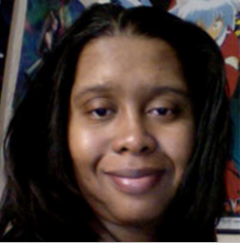
Heather Hummons

New CALL member, Heather Hummons, is the Head of Access Services at DePaul University College of Law. Fellow Call Bulletin Committee member, Jill Meyer, recently interviewed her so we could get to know her.

JM: How did you get your start working in libraries?
HH: I actually started working in libraries back in 2000 as a part-time circulation clerk. As the years progressed, I received several promotions within that department beginning with a transition to the part-time weekend circulation supervisor to a full-time position as a Library Assistant I, functioning as the primary circulation desk attendant and in charge of library billing. When the position for Circulation Manager opened in 2004, I applied and was hired. I remained in that role until last year (2014) when I was promoted to my current position as the Head of Access Services.

JM: What brought you to your current position?
HH: Recently, several positions opened due to retirements. I was already serving as the Circulation Manager (having been in this position for ten years) and about to start school at Dominican University’s Graduate School of Library and Information Science. As a result of some restructuring by the Law Library Director, I was promoted to the Access Services Head position. I’ve worked every aspect of Circulation throughout the years including supervising and managing personnel, as well as providing back-up support for other positions in the circulation department including interlibrary loan and handling print reserves. I am also highly vested in providing quality customer service, which is one of my favorite parts of the job. There’s something wholly rewarding about helping someone answer an information need. I thrive off providing service and couldn’t imagine working in an environment that didn’t allow me the collaboration with people that libraries provide.

JM: What is your favorite part about your current job?
HH: It’s hard to choose. I really enjoy working with people, so the direct service and management of people are both equally rewarding. Although, if you had asked me this question ten years ago, I would have never imagined I would be in a position managing people. As I mentioned before, there’s something wholly gratifying about helping people fulfill their information need as well as collaborating with others towards a common goal. I also enjoy space planning. Since taking this role, I’ve worked on several renovation/reconfiguration projects that have utilized my skills in a different way while addressing library facility and patron needs.

JM: Since you are currently in school, what is your favorite class so far, and why?
HH: My favorite class thus far was one I just took this summer—LIS 885: Cultural Heritage Resources and Services. Although I have to admit that the class I took this Spring, LIS 796: Special Topics Bologna Children’s Book Fair in Bologna, Italy, was pretty awesome too. LIS 885 invoked critical discussion about who owns culture and explored themes such as representation, ethics and stewardship as they relate to community, cultural memory, curation and preservation of cultural records, as well as questions of cultural integrity. Matters regarding the protection of cultural heritage are extremely important to me, as I feel this plays an integral part in identity and community. Loss of cultural heritage can have devastating and irreversible consequences for a community and the world.

JM: Where did you grow up?
HH: I’m a native of Chicago, growing up predominantly on the West side of the city.

JM: Why did you decide to join CALL?
HH: I joined CALL mainly for the networking opportunities and community aspects it offers. CALL is the first organization I’ve joined since I began pursuing my MLIS. I’m looking forward to being actively engaged in a library professional community where I can share my experiences, gain experiences that will expand my knowledge in law librarianship, and meet new people in the field. Working in a law school library for 15 years, I believe I have a wealth of experiences dealing with the legal community that will make my membership with CALL very rewarding.

JM: What do you enjoy doing outside of work?
HH: I enjoy spending time with my family when I’m away from work, as they are my support network. I’m also an avid fan of Japanese popular culture and videogames. I watch a lot of anime, read lots of manga, play videogames, listen to video game and anime soundtrack music and occasionally cosplay. I enjoy going to anime conventions and concert performances featuring the music by the famous composer Nobuo Uematsu for the Final Fantasy Soundtracks. I also enjoy when I can incorporate what I love to do with my work. We host a Halloween event every year for the law students, and the library staff members dress up and pass out treats. One year I dressed up as the executioner from the videogame “Resident Evil 5” (I built the hammer as well). The law students loved it! One of them knew right away what character I was dressed up as which sparked a conversation about our common hobby—playing videogames. The added bonus was I got to meet a student I had not talked to before. Overall the event was great for providing the students a momentary break from studying as well for library promotion and community outreach.

JM: Anything else that you would like to share?
HH: I have a BA in Multimedia Arts and Japanese Studies and an MS in Cinema Production with an Animation Concentration from DePaul University. Additionally, I was recently named a 2015-2016 Spectrum (ProQuest) Scholar by ALA’s Office of Diversity.

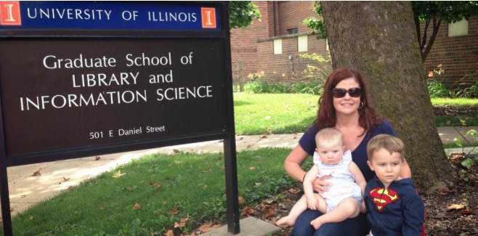

LEEPING INTO THE LAW LIBRARIAN PROFESSION: A GLIMPSE INSIDE THE UNIVERSITY OF ILLINOIS LEEP PROGRAM “BOOT CAMP”
LEIGHANNE THOMPSON
I recently made the “leap” from practicing ERISA law to pursuing a Master of Library and Information Science (MLIS) degree at the University of Illinois Graduate School of Library and Information Science (GSLIS).
I enrolled in the GSLIS LEEP program, a program that combines web-based education with a 7-day residential “boot camp.” The boot camp is a 2-credit class titled “Libraries, Information and Society” that is intended to provide a broad framework for thinking about the social, economic, and political issues faced by members of the library and information professions.
In prior years, the program required an initial residency of 10-14 days and students were also required to attend some classes on-campus each semester. The current LEEP program only requires the 7-day residency.
With boot camp being shortened to 7 days, each day was completely filled with lectures, group discussions, group work and writing assignments. Scheduled lectures and group discussions generally took place between 9:00 am and 5:00 pm and group project work and paper-writing generally took place between 5:00 pm and 10:00 pm. A group project, including a poster presentation, was due the last day of boot camp.
I had brought my 9-month old daughter with me to Champaign for the week, but I quickly realized that this was overly ambitious given the workload demands. Thankfully, my husband was able to pick her up and drive her home before the final few days of boot camp, when the workload peaked.
The theoretical issues presented and the collaborative group projects were almost a surreal experience for me, having just left the practice of law at a large law firm a few days prior to starting boot camp. The collaborative environment, combined with the long days, facilitated instant camaraderie among students. I feel much more engaged with fellow students and administrators than I would have felt if the entire program was accomplished through distance learning.
Of the many interesting topics we discussed, including copyright issues, access issues, and preservation issues, I find two issues particularly interesting and thought-provoking as I enter the profession.
First, we addressed the challenges related to the valuation of library services. When I announced my decision to pursue an MLIS to friends, I was confronted with the response, “Why would you do that? The librarian profession is dying.” This response made me realize that not only must librarians constantly innovate to keep pace with this digital world, but librarians are also faced with the difficult task of assessing and communicating the value of services provided. The discussion at boot camp highlighted some of the difficulties of applying common valuation metrics to library services.
The second issue I found particularly interesting is the current climate surrounding privacy and government surveillance in library and technology-based contexts. Despite the recent sunsetting of the controversial “library provision” in the USA Patriot Act, it is clear that librarians and information professionals will continue to play an important role in advocating for important civil liberties.
My experience at boot camp confirmed my belief that this is an exciting time to become an information professional—a time when creativity and innovation may be more important than ever. I am excited to complete my journey through the LEEP program!

CALL LIBRARY SCHOOL EXPERIENCE

STACIA STEIN

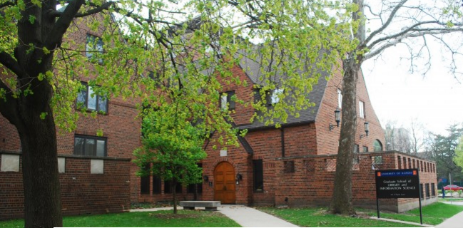

Stacia Stein

Why do I get myself into these things?! This is a question I have asked myself a lot this year. In fact, I am asking myself that very question right now, as I stare at a blank computer screen, reflecting on my first year in library school, trying to find some sort of form and poetic resonance in my experience.
It’s a question that I asked myself last summer when I attended “bootcamp” at the University of Illinois, the mandatory 1-week introductory course in Champaign for students intending on pursuing their MLIS degree online … 4 quizzes, 2 papers, 1 group presentation and required active participation in live classes as well as internet message boards that never sleep! It’s a question that I asked myself last fall when the class I was taking wasn’t resonating with me. Because the class was online, I had no way of knowing if this disconnect was a sign that I had maybe made the wrong career choice or if, in fact, other students were feeling it too. And, yes, it’s also a question that I asked myself Spring Semester, when I took two inspiring and challenging classes but struggled to find the time to balance work, school and life.
The classes in government documents and legal research were finally starting to make law librarianship feel real and exciting to me. I wanted to spend every minute studying but where was I going to find the time to do everything and to become the librarian I wanted to be? The answer however, is in the question itself. Librarians are seekers. They may not always have the answers but they know where to find them and they relish the search. This search is what drew me to the profession and, I suspect, it is what will keep me there. I get myself into these things because I can’t help but ask questions and look for answers all of the time.

One of the biggest questions I confronted during my first year in library school was how to best navigate the online classroom and, most especially, how to embrace the message board. My classmates all seem so brilliant! I’ve read that students in live classrooms often struggle with the pressure of having to appear perfect online. In a virtual classroom, you can imagine just how perfect everybody appears. Comments are always well thought out. There are never yawns or eye rolls or sighs during a discussion topic. There is nothing negative at all. What monster would want to bring a negative thought into this utopia?
The online message board encourages one to engage with and think critically over the readings, as well as to forge connections with classmates whom one may never see in person. However, these message boards can be a little intimidating and I struggled with them. I wanted to project myself as being as smart and insightful as my classmates but — what if I’m just not? My solution, again, was a question. In fact, lots of them. If a classmate had an incredible insight, I’d ask about it, at the risk of sounding dumb myself. As I practiced engaging with my classmates on the online forums, I found that I became less intimidated and eventually had more to say. While I am still struggling with the pressure to be brilliant, I am getting more out of my classes by just setting aside an hour or so a week for the struggle. Entering into the online conversation has been rewarding and I am a more satisfied student because of it.
This fall, I will be working as a Reference Associate at the Pritzker Legal Research Center as well as working on a Practicum there. The question that I am anticipating next is: How will the skills I’ve learned so far translate into the actual practice of law librarianship? I can’t wait to find the answer!

AALL ANNUAL MEETING AND CONFERENCE 2015: A NEWBIE’S JOURNEY
CLANITRA STEWART NEJDL

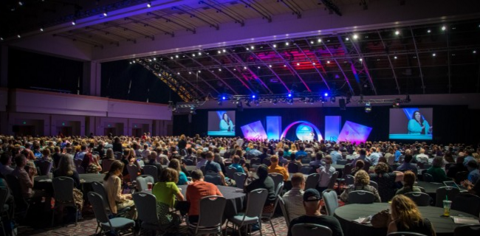
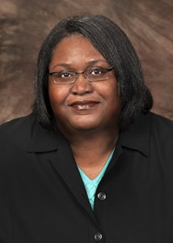
Clanitra Stewart Nejdl
Being a novice at something can create at least some degree of apprehension. Someone who, for example, has never piloted a plane would probably be pretty nervous about his or her first takeoff. And it goes without saying that a singer’s first concert ever likely creates at least one or two beads of sweat. In my case, apprehension hit me while preparing to attend my first American Association of Law Libraries (AALL) Annual Meeting and Conference.
Now, please don’t get me wrong. I was extremely excited about the prospect of meeting and learning from so many of the knowledgeable and talented veteran law librarians I read about in publications like AALL Spectrum and Law Library Journal. My wonderful colleagues only heightened that excitement when they warmly shared with me their stories of AALL conferences past.

My apprehension simply came from the prospect of interacting with so many of them in such a short amount of time while being, to be blunt, a bit of an introvert. Additionally, the 2014-2015 academic year was my first as a law librarian, so I admit that being relatively new to the field made me feel somewhat intimidated. Stated plainly, my pre-Meeting mindset could be summed up by a rather simple formula: Introversion + Intimidation – Experience = Plain Old Apprehension.

Fortunately, I have never been one to let my fears hold me back. So, on July 17, 2015, I set off from DeKalb, IL for Philadelphia, PA with a small amount of luggage and a very full itinerary. As part of my planning for the Annual Meeting, I had not only consulted my colleagues, but also read several columns and tips from former Annual Meeting neophytes. I knew from this collective wisdom that my best bet for a successful first Annual Meeting was to attend CONELL, to select conference sessions carefully, to pace myself, and to take some time to enjoy what Philadelphia has to offer its visitors. Over four days, I followed this advice carefully. As a result, there were quite a few parts of my first Annual Meeting that I will never forget.

CONELL 2015
By far, the highlight of my Annual Meeting experience was participating in CONELL. CONELL Committee Chair Emily Janoski-Haehlen and her dedicated team of volunteers created a fun and educational environment in which we newer law librarians could meet the AALL President and Executive Board, learn about publishing opportunities in the AALL Spectrum and the Law Library Journal, consider leadership and mentorship possibilities, discover AALL Special Interest Sections and Caucuses to join, and get to know each other through quick speed networking activities. A few of us even got the rare opportunity to meet a couple of very famous prairie dogs.

After the morning sessions concluded, the “CONELL Class of 2015” gathered for lunch and then ventured into the city for the Colonial Philadelphia Experience tour. For an event that lasted only one day, CONELL provided a surprising number of notable experiences.

Educational Programs
One drawback of any professional conference is that no attendee can attend all of the educational programs available. This was definitely the case at the 2015 Annual Meeting. Each day provided several hours of timely and relevant educational programs that covered diverse topics including cataloging, library management, collection development, reference and research services, and legal research instruction.
Unfortunately, many of my own personal “must attend” programs were scheduled at the same time. Although it was difficult to decide, I opted to attend the one educational program in each time slot that seemed the most critical to attend in person. However, my disappointment at being unable to attend the conflicting programs was tempered by the knowledge that I could virtually attend them later by listening to the AALL 2015 session recordings (available athttp://www.aallnet.org/conference/education/2015recordings).

The Exhibit Hall
To be sure, the most intense part of my Annual Meeting experience was visiting the Exhibit Hall of the Philadelphia Convention Center. In the Exhibit Hall, a seemingly countless number of vendors showcased their legal information products and services while giving away everything from pens and lanyards to iPads and gift cards.
My plan had been to visit the limited number of vendors I was familiar with to learn about new developments in their products, and then to broaden my knowledge base by visiting a few unfamiliar vendors. However, upon entering the Exhibit Hall, I quickly found myself caught in thrall of unique displays, comfy couches, multiple-part presentations, and an adorable giant cheetah.
Over the course of the four days, I spent each break between educational programs drifting from booth to booth, eyes glazed, and bag growing heavier with law librarian “swag.” By the end of the Annual Meeting, I had seen numerous product demos, learned about many types of legal information services, and gathered more pens, stress balls, magnets, and flash drives than I could reasonably hope to use in the entirety of my career.

Philadelphia Sights and Cuisine
In those very few hours in which Annual Meeting activities and events were not scheduled, I forced myself to leave the comfort of the air-conditioned hotel to experience some of the city. Bus tours were readily available outside of the hotel, and my husband and I took the opportunity to see the city from a double-decker bus.
Quick stops allowed us to run up the stairs of the Philadelphia Museum of Art à la Rocky Balboa, photograph a cast of Rodin’s The Thinker, see Benjamin Franklin’s grave, and gaze out onto the Delaware River via Penn’s Landing. Adding to the delights offered by the city, local venues like Reading Terminal Market and Campo’s Deli provided a variety of delicious fare including Philly cheesesteaks, Soul food, gourmet candy, and crêpes. To my surprise, there was even a Maggiano’s Little Italy across the street from the hotel!

Needless to say, my original apprehension was unwarranted. The 2015 AALL Annual Meeting and Conference allowed me to meet many welcoming and kind law librarians, as well as learn much more about the nuts and bolts of our profession. If every Annual Meeting is as wonderful as this one, then I definitely can’t wait for AALL 2016 in Chicago.

A NEW LIBRARIAN GOES TO AALL
SIMONE SRINIVASAN
As someone new to Chicago and new to law librarianship, I was somewhat surprised to find myself, a mere two months into my new job as a reference librarian, jetting back to my home state of Pennsylvania to participate in the 2015 AALL conference.
It would be my very first conference, and I had no idea what to expect—of the programs and workshops or of my fellow librarians. In library school, we had felt the effects of an ongoing tension between researchers and practitioners. We had all been frustrated by endless discussions of the true meaning of information and were tired of climbing the data-knowledge-wisdom pyramid. A classmate had gone to a conference in Vancouver and returned bearing tales of irate practitioners berating researchers over the irresponsibility of small sample sizes. I wondered if those debates were what awaited me in Philadelphia.
My first stop was the Conference of Newer Law Librarians (CONELL). There, at eight in the morning, I met my cohort: numerous academic librarians, private law librarians, government librarians, current students, and recent grads, all of us new to the profession, all of us bursting with enthusiasm. We swapped cards, shared experiences, and confided in one another our confusion about the rainbow of available ribbons. Speed networking was chaos—so many faces and rapid-fire questions and answers, punctuated by the gentle sound of an organizer’s train whistle. I was eager to know how my fellow librarians had gotten to where they were, whether or not they had planned to specialize. Some seemed to have moved in a straight line: They had always known they wanted to be librarians, or more specifically, law librarians; for some, librarianship even ran in the family. Others, like me, had taken more meandering routes, moving from subject to subject or even from one end of the country to the other. We were united in our curiosity about one another. Wandering from booth to booth in the Special Interest Sections Marketplace, I played the CALL member guessing game and greeted a vibrantly colored, life-sized cardboard cutout of Francis Bacon at the Legal History & Rare Books table.

On Sunday, we all gazed starry-eyed at Terry Gross, our keynote speaker, whose talk highlighted the difficulties and splendid rewards of good research and good communication. Perhaps more seasoned librarians recognized elements of their professional lives in her stories about her interviews with Hillary Clinton, Gene Simmons, or Maurice Sendak. (One can only hope that Gene Simmons-esque reference interviews are few and far between.)

Then it was on to the programs—the seminars, panels, lunches, talks, tutorials, and deep dives. I attended fascinating sessions about cross-border arbitration, legal project management, career development, and competitive intelligence (a jovial and entertaining panel delivered in the style of a late-night gameshow) and coding. As a newcomer to the field, I was interested in learning more about best practices in each of these areas: how to interact with clients, how to package and deliver information effectively and in a visually appealing way, how to navigate the increasing number of resources at our disposal to find the best possible information.
It was a whirlwind weekend, the speed and saturation of the experience intensified by a delirium caused by airport delays and an unexpected red-eye flight. The conference was imbued with a spirit of collaboration and exploration. My colleagues, who had attended the Private Law Librarians & Information Professionals SIS’s Innovation Summit along with numerous other sessions, left the conference with their heads and notebooks full of ideas for how we could market and expand our services. A month after AALL, we’re still talking about some of the sessions and how we can continue to implement the ideas we gathered in our day-to-day practices and long-term projects.
As for me, I returned to Chicago both energized and reassured. I’d met so many different kinds of librarians and learned so much about their roles, their projects, and their plans for the future of their libraries, no matter the sector. Together, we are in the midst of great change, facing immense uncertainty and incredible opportunity. After AALL, whatever the future holds for our profession, I know I’m in good company.

USING SUCCESSION PLANNING AND KNOWLEDGE TRANSFER TO CONNECT THE GENERATIONS

JOANN HOUNSHELL

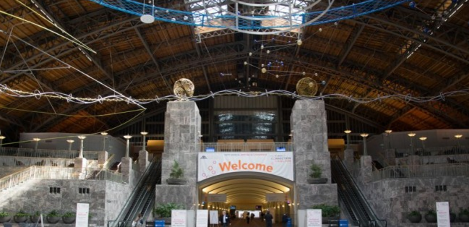

As a freelance reporter for the CALL Bulletin, I wanted to track down the most interesting and informative programs at the 2015 AALL Annual Meeting in Philadelphia. There were many excellent programs to choose from, and it should come as no surprise to the membership that CALL was well represented in the annual meeting programming.

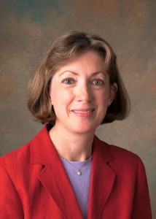
Sally Holterhoff

One program in particular was a standout. Sally Holterhoff (Valparaiso University) co-coordinated the program, Using Succession Planning and Knowledge Transfer to Connect the Generations. Speakers, Deborah Rusin (Katten Muchin Rosenman, LLP), Katrina Miller (Florida State University), Steven Barkan (University of Wisconsin), and Ann Marie Dimino (Blank Rome, LLP) described their experiences in identifying challenges and opportunities as their library prepared for retirements, and loss of positions through attrition.

No one could predict the sea change in the legal industry that has impacted law school curriculums, class sizes, and staff needs in all types of law libraries. As many library prognosticators predicted in the late 1990s, the baby boomers among us are now retiring. What has developed is a perfect storm for significant organizational change in law libraries. Using Succession Planning and Knowledge Transfer to Connect the Generations provided timely discussion on what all libraries are facing.

Succession planning requires library leadership to strategically plan the professional development of the staff to assume key roles within the library. Planning must be deliberate and not reactive to safeguard institutional knowledge, or the library will risk losing momentum.
The first step in developing a succession plan, or a legacy plan according to Steve Barkan, is to acknowledge the need for succession planning. Evaluate the library’s situation. Who could be retiring in the next 12 months, 24 months, 48 months? It is essential to engage the potential retirees in discussing legacy planning as early as possible.
Succession planning should be transparent. Transparency requires open and honest communication. This process can also be seen as an opportunity to identify emerging talent among the staff. It can also provide staff with professional development opportunities that in the end will move the library forward.
Key to succession planning is the development of a knowledge transfer plan. Cross-training is essential, and cannot start early enough based on the experiences described by Deborah Rusin and Katrina Miller. Cross-training should be the priority of the library and embedded in its culture. The training should include the most basic daily tasks to duties that occur on an irregular basis. Vacations can become opportunities to track activities that should be incorporated into a procedures manual and into cross-training. No process is too insignificant to document.
Succession planning may be uncomfortable to contemplate, but it does not have to be difficult. The key according to Ann Marie Dimino is to get the staff involved and have honest, open communication. Compassion and mindfulness will go a long way into making succession planning effective.
This was a timely, thought-provoking program. Succession planning, or legacy planning, is a tool that will allow the library to strengthen its position within the organization.

CALL GRANTEE REPORT FROM CAROLYN HERSCH

CAROLYN HERSCH

As a recipient of CALL’s grant to the annual conference, I attended the 2015 AALL Annual Meeting & Conference in Philadelphia. Although I am not a complete conference novice, having previously attended Special Libraries Association (SLA) conferences in 2012 and 2013, this was my first time at AALL.
I went to the Private Law Library and Information Professional (PLLIP) Summit, held on the Saturday before the conference officially kicked off. The summit consisted of an Innovation Tournament, led by Karl T. Ulrich, Vice Dean of Innovation at Philadelphia’s Wharton School of the University of Pennsylvania, and co-author of Innovation Tournaments: Creating and Selecting Exceptional Opportunities.

Attendees broke out into small groups, and came up with an innovative idea to answer the question “What new information products or services (deliverables) can librarians provide to strengthen their firm’s relationship with current or prospective clients?” All of the ideas were shared, and then all the attendees could vote for four of their favorites. My group’s innovative idea was called “MyCase,” geared towards facilitating the process of getting documents from clients for ongoing case matters. It did not win the tournament, but it did earn 13 votes.
Afterwards, there was a discussion on how to come up with innovative ideas, the trajectory of innovation, and the painful process of coming up with ideas which actually have merit. Following this were presentations from different speakers on the innovative ideas that were implemented at their firms.
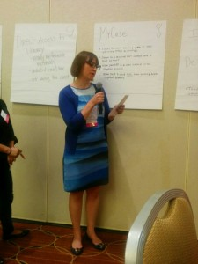
Carolyn Hersch

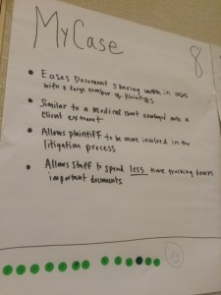
MyCase

As an incoming member of AALL’s Copyright Committee, I was able to attend the committee meeting, as well as meet with David Mao, the Law Librarian of Congress. He filled both the Copyright Committee and Government Relations Committee in on the happenings of Congress with respect to both copyright issues as well as other issues of importance to AALL members.
The keynote address was delivered by NPR’s Terry Gross. It was an excellent speech where she discussed various people she’d interviewed over the years. Although she had many memorable points within her speech, she indicated at one point that she depended on NPR’s research librarians to assist her with research to appropriately prep her for her interviews.
As a first time attendee, I wanted to really maximize my experience, and I tried to take advantage of everything offered to first timers outside of CONELL. I participated in the AALL Annual Meeting Host Program, which matched me up with Cameron Gowan, the Library Services Manager at Jones Day. It was a really excellent match, and she showed me the ropes of the conference. We sat together at various programs, and she was very helpful in introducing me to people.
One of the challenges of choosing programs to attend was that I wanted to check out everything! I went to numerous sessions on competitive intelligence and how to advance CI within our own workplaces. Our CALL colleague (and my boss), Diana Koppang, presented “Best Practices for Client Ready Deliverables,” where I was used as an example of how to do things, and how not to do things, when creating materials which are ultimately sent on to clients.
One of my favorite programs also involved CALL members Debbie Ginsberg and Emily Barney, who presented “In the Wake of the Kia Audit: Training Law Students and Lawyers on Legal Technology Skills.” Many of the points that they touched on were points I’ve heard before, but were very accessible and remain relevant.
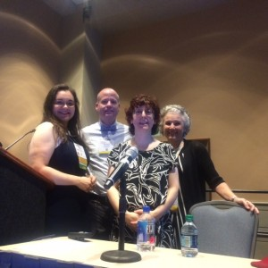
Emily Barney and Debbie Ginsberg

I volunteered for two shifts at the Local Arrangements Booth. The excitement that non-Chicago-based AALL members had regarding the 2016 conference was palpable. All in all, this was an excellent conference which only makes me more excited for next year!

KEITH ANN STIVERSON, AALL PRESIDENT
LINDSEY ANN CARPINO

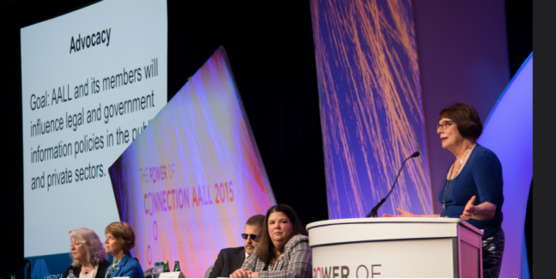
Keith Ann Stiverson

The CALL Bulletin Committee would like to congratulate Keith Ann Stiverson on her role as AALL President. [For more details, see the August 17, 2015 AALL press release and the August 14, 2015 Chicago Daily Law Bulletin at 3] Keith Ann has chosen the theme of “Make It New: Create the Future” for the 2016 Annual Meeting in Chicago. I know we are all looking forward to this conference!

Best of luck to you, Keith Ann!

CALL COMMITTEE ROUNDUP

ANNIE MENTKOWSKI, BETTY ROESKE, EUGENE GIUDICE, JAMIE SOMMER, JESSE BOWMAN, JESSICA LEMAR, JOE MITZENMACHER, JULIE SWANSON, KARA YOUNG, KARL PETTITT, LYONETTE LOUIS-JACQUES, MARGARET SCHILT, MARIBEL NASH

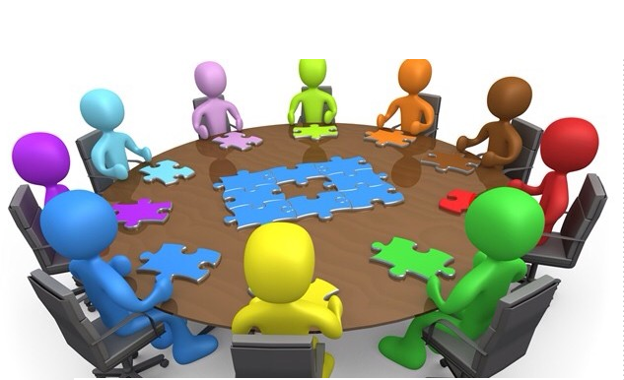

The Committee Roundup is a new CALL Bulletin featured column where all of our committees will provide an update for us each issue to let us know what they are working on. In this issue, the committees focused on their goals for the upcoming year.

Archives Committee Goals:
Co-Chairs: Therese Arado and Annie Mentkowski
Members: Sharon Nelson
- We continue to digitize, where appropriate, CALL materials. In addition, we are working to preserve the website. Please continue to send the Co-Chairs all materials that need to be archived. See the CALL guidelines for more details on what should be archived

Bulletin Committee Goals:
Co-Chairs: Lyonette Louis-Jacques, Scott Vanderlin, and Lindsey Ann Carpino
Members: Emily Barney, Debbie Ginsberg, Juanita Harrell, Philip Johnson, Annie Mentkowski, Jill Meyer, Stacia Stein, Clanitra Stewart Nejdl, LeighAnne Thompson
- Publish regular columns on CALL committee activities, law firm librarianship, library school, Illinois government relations, reports on CALL continuing education programs, as well as interviews with new CALL members
- Solicit articles on SLA, SLA-Illinois, ILTA, MAALL, 3L (Leaders of Law Librarianship) and other related law and library associations and groups
- Publish profiles of CALL member libraries (the 7th Circuit, for example)
- Publish an article about the work of the new Bulletin Historian, Annie Mentkowski
- Arrange for the CALL Bulletin to be included in HeinOnline
- Create opportunities for CALL members to write for and contribute to the CALL Bulletin
- Solicit and publish Bulletin articles on topics suggested by CALL members in CALL President Julie Pabarja’s recent survey
- Collaborate with the PR and other CALL committees to publicize and promote the work of CALL and its members

Community Service Committee Goals:
Co-Chairs: Julie Swanson and Lucy Robbins
Members: Susan Retzer, Jennifer Lubejko, Joanne Kiley, Jamie Stewart, Simone Srinivasan
- To collaborate with other CALL committees, to communicate effectively with committees and members, and to seek and coordinate volunteer events that will foster a sense of community service and networking opportunities for members

Continuing Education Committee Goals:
Co-Chairs: Jessie Bowman and Carolyn Hersch
Members: Sharon Nelson, Philip Johnson, Tom Keefe, David Rogers, Jamie Stewart, Simone Srinivasan
- Greetings from the Continuing Education Committee! We’re still in the very early stages of planning, but we’re excited to offer a variety of informative and relevant programs throughout the next year
- Tentatively speaking, we hope to provide either in-person or virtual events during months in which a business meeting is not being held
- Although it’s still nine months away, we’re also beginning to brainstorm ideas for Institute Day next May
- Please feel free to email either Jesse Bowman (jesse.bowman@law.northwestern.edu) or Carolyn Hersch (chersch@ngelaw.com) with any suggestions for programming. We hope to see you at an in-person or virtual event soon!

Corporate Memory Goals:
Chair: Betty Roeske
Members: Judy Gaskell, Christine Morong, Susan Siebers, Frank Drake
- Review the Board minutes. Update Policy Log as needed
- Review Policy Log against the CALL Handbook

Grants and Chapter Awards Committee Goals:
Chair: Margaret Schilt
Members: Clanitra Stewart Nejdl, Lyonette Louis-Jacques, Beth Schubert, Patricia Sayre-McCoy
- This year’s Grants and Chapter Awards Committee is hoping to receive grant applications for a wider variety of professional education opportunities, as well as for the AALL Annual Meeting, to be held here in Chicago next summer
- Please review the grant application athttp://new.chicagolawlib.org/download/CALL-GRANTS-APPLICATION-2015.pdf and consider applying for a grant

Government Relations Committee Goals:
Co-Chairs: Joseph Mitzenmacher and Clare M. Hoyt
Members: Tom Gaylord, Sally Holterhoff, Justin Franklin
- We are in the process of finishing our updates to Finding Illinois Law: A Librarian’s Guide for Non-Lawyers. In addition to publishing the updated PDF version of the Guide, we are also going to be looking at options for publishing the Guide in a more dynamic format
- We are going to be writing a regular Bulletin article updating the membership on state and federal legislative items of interest to CALL members
- We are also soliciting ideas for subjects to track, so if anyone has ideas or sees anything of interest that falls within our scope of coverage that you’d like to see us write about, please let us know

Meetings Committee Goals:
Chair: Eugene Giudice and Larissa Sullivant
Members: Jill Meyer, Sara Baseggio, Todd Hillmer
- Your Meetings Committee will strive to find meeting venues that will help contribute to a successful meeting, greater attendance and good value for money spent
- This year, we have found at least two new venues and are experimenting with more buffet style lunches (as opposed to plated meals)

Membership Committee:
Co-Chairs: Therese Arado and Annie Mentkowski
Members: Christine Klobucar, Lindsey Carpino, Jeff Meyerowitz
- Membership renewals will be moving to an online platform called Wild Apricot. This means, in the very near future, you will be able to renew your membership online and pay your dues via credit card. Wild Apricot will also speed up the directory publication process.

Mentorship & Leadership Development Committee Goals:
Co-Chairs: Jamie Sommer and Clare Willis
Members: Tom Gaylord, Gretchen Van Dam, Ben Brighoff
- The MLDC had a great turn out for its first meet-up in July 2015 as everyone was preparing for the AALL Annual Meeting. Over the next year, the MLDC plans to host additional networking events, including roundtable discussions where members with similar responsibilities and interests can informally meet to discuss topics and trends
- In the coming months, the Committee plans to formally announce the CALL mentorship program and will be asking anyone who is interested in having a mentor or serving as a mentor to sign up
- Finally, based on feedback from the CALL Membership Survey, we will also be working with the Continuing Education Committee on developing programing related to leadership and management skills

Nominations & Elections Committee Goals:
Chair: Maribel Nash
Members: Carolyn Hosticka, Tom Keefe, Sheri Lewis, Jean Wenger
- Excited to put together a great slate of candidates for CALL’s 2015-2016 term. Please start thinking about who you would like to see on the CALL Board!

Placement and Recruitment Committee Goals:
Chair: Karl Pettitt and Jessie LeMar
Members: Valerie Kropf, Gretchen Van Dam
- We recently held our first committee meeting and we are working on ways in which we can further engage the legal community as well as Library & Information Science students
- While we will continue to manage the job postings for the CALL website and listserv, we discussed other ways we can collaborate with various CALL committees in the upcoming year
- The committee is hoping to reach out to more regional library schools and law schools to promote the CALL job board
- We will also be making changes to the job postings form on the website
- As a reminder, if there is a position available at your library please consider taking a moment to promote CALL by letting your human resources or hiring manager know about our job postings!
- We have found a brochure that was previously used to advertise our committee’s services to law firms in their recruitment efforts. An updated version is pending

Public Relations Committee Goals:
Co-Chairs: Kara Young and Beth Schubert
Members: Debbie Ginsberg, Emily Barney, Lyonette Louis-Jacques, Joanne Kiley, Sharon Nelson, Scott Vanderlin, Britnee Cole
- Make website improvements based on recommendations from last spring’s website task force
- Continue to explore/expand CALL social media presence (live-tweeting meetings, etc.)
- Streamline the backend of the website

CALL EXECUTIVE BOARD MEETING MINUTES – JUNE 2015
DIANA KOPPANG

2014-2015 CALL EXECUTIVE BOARD MEETING
Complete, up-to-date CALL Board meeting minutes are available on the CALL website.

- AALL Headquarters, 105 W. Adams St., Suite 3300 (enter on Clark St.)
- June 9, 2015 9:00 a.m.

Board Members Present
- Margaret Schilt
- Robert Martin
- Konya Lafferty
- Julie Pabarja
- Todd Ito
- Diana Koppang

Board Members Absent
- Stephanie Crawford

Guests
- None

Summary

Treasurer’s Report (Section IV):
- Harris Bank Balance as of May 31, 2015: $27,489.52
- Net Income, May 31, 2015: ($704.12)
- Membership Numbers as of May 31, 2015: 258* (2 New Members, 3 Renewals) *based on April member numbers as May is a transition month for renewals.

Significant Actions
Policy Changes: Website Administrator will be appointed by the CALL President.

CALL LEADERSHIP ORIENTATION 2015

JULIE PABARJA, KONYA LAFFERTY
CALL Leadership Begins Year with Orientation
Board members and committee chairs met on August 13, 2015, for CALL’s Leadership Orientation. It was hosted at DLA Piper. President Julie Pabarja led the orientation for 23 members to help prepare committee chairs and Board members for their roles as leaders in their committee and the greater CALL community.

New and Experienced Leaders
This year, President Pabarja appointed eight members who will be serving as Committee Chairs for the first time. Many of the other committee chairs are experienced chairs and leading a new committee. These chairs will bring new perspectives to the committees and the chance to demonstrate and enhance their leadership skills.
Vice President Todd Ito, along with Board Directors Robert Martin and Konya Lafferty Moss, reviewed the Chairs’ administrative responsibilities and highlighted the CALL documents, including the Handbook and Policy Log, that they can turn to for guidance.

The group discussed the characteristics of a good leader and how to engage members of their committees.
Pabarja highlighted the results of the CALL member survey that was sent to the membership earlier this summer. Overall, the members are satisfied with the value that CALL offers its members. They would like CALL to offer more education and networking opportunities.

Collaboration and Growth
Pabarja talked about ways the committee chairs can collaborate with each other and provide more of these opportunities to the membership. Chairs from the Continuing Education, Public Relations, and Bulletin committees spoke on ways that the other chairs can work with them to meet certain goals.
The group also discussed ways they could share with the membership what their committee is working on and generate interest in what the committees do. This year, each committee will make a regular contribution to a new “Committee Roundup” section in the CALL Bulletin. CALL members can also look at the CALL website for the committees’ latest news.

Time was allowed at the end of the session for Chairs to talk to each other and start making plans for a great year for CALL.

Getting Involved
Members who are interested in joining a committee should contact Julie Pabarja. The following committees are looking for more members: Government Relations, Public Relations, Continuing Education, Mentoring and Leadership Development.

WHAT’S BUZZIN’?
ANNIE MENTKOWSKI, DIANA KOPPANG, LINDSEY ANN CARPINO
What’s Buzzin?, a new brown bag series designed to foster more collaborative relationships between firm, government and academic librarians debuted on September 11, 2015, at DLA Piper. This was the first of what is sure to be many informal discussions and exchanges of ideas among CALL colleagues. Julie Pabarja, Lindsey Carpino and Annie Mentkowski led the inaugural discussion. And, a special “thank you” to Diana Koppang who volunteered to take notes.

Topic: What do academic law librarians teach the law students in law school? What skills do law firm and court librarians wish new attorneys learned in law school?

The first What’s Buzzin’ discussion had a nice mix of firm, academic and government librarians. Annie & I shared that we would be presenting at the MAALL Conference in Kansas City in October on “Everything’s Up to Date Preparing Practice Ready Students.” We thought it was fitting to host a round table on this topic and gather feedback for our own presentation. We showed everyone our Prezi and handout for MAALL. These highlighted the 5 topic areas that we plan on covering at the conference: Billing, Technology, Research 2.0, Law Firm Resources & Professional Skills. After getting feedback, we then asked the following questions:

Academic Library Questions:

What do you teach your students? More specifically are Digests and Headnotes being taught?
Yes in law schools, but it doesn’t seem to stick with new practicing attorneys. A significant number of law firms are no longer subscribing to digests. Some law schools are cutting back on multiple copies – again due to costs. This makes it difficult to teach the digest with only one copy. Konya Lafferty suggested creating a video to teach the digest to cut down on heavy in-class use with limited copies. Plus law schools have to teach multiple digest styles (Lexis v. Westlaw v. Bloomberg for example).
Diana Koppang suggested creating a CALL survey of law firm, academic and court libraries as to what titles are being cut. Julie Pabarja is currently in the process of drafting this survey to be sent out to members.
What resources can you access?

Resources used in Law Schools: Westlaw, Lexis, Bloomberg, CCH, Checkpoint, Proquest, BNA, HeinOnline, EBSCO, JStor, Practical Law, E-Books (Westlaw & Lexis), Clio and Free sources used for legislative history, law reviews and Google Scholar.

How do you “stay in touch” with what actually happens at a firm?
By reaching out to our colleagues in firms and staying on top of current awareness. Some law schools even have programs where they invite librarians in to present – how to survive your summer internship or lecturers for specialty research topics (such as Intellectual Property).
Firm/Court Library Questions:

What resources can you access?

Resources used in Law Firms: Docket tools (PACER, Court Link, Court Wire), Securities (Intelligize, Securities Mosaic), Intellectual Property, People/Public records (Accurint) and Tax & Other Specialty.

What skills do you wish new attorneys have?
An overall knowledge of digests, headnotes, using an index from print resources, billing, the Document Management System (DMS), technology, security issues and metadata.
What are your pain points with new attorneys?
Law firms struggle with new associates’ researching skills, but academic librarians are facing the challenge of not being given enough time to teach advanced research. Firm librarians wish new attorneys were comfortable using an index within a print resource. Also, there is a huge gravitation toward Google-like searching with students and new research platforms using a simple search feature. Additionally, firm librarians struggle with some new attorneys’ lack of basic civil law knowledge, such as how a bill is created and their ability to find material outside of primary law – such as ordinances, deeds and statutory material.
How can we collaborate/communicate with each other in the law librarian community?
- More round tables
- Reach out to each other, talk, lunch
- See where new associates went to law school and reach out to those librarians
- Bring in partner, librarian and secretary to the classroom

Other discussion points:
We wanted to encourage attorneys to talk to librarians about Westlaw and Lexis charge back fees and to think of us as the safe zone. We do not want attorneys to be afraid to use these resources we are already paying for. We all agreed that law students should continue to be taught Boolean & Terms and Connector search strategies. We should focus on the overall searches rather than teaching a specific platform as they might not have that resource in practice. Finally, we should arm students with the questions they should be asking when they start their legal careers.

CALL MEMBERSHIP SURVEY RESULTS
JULIE PABARJA

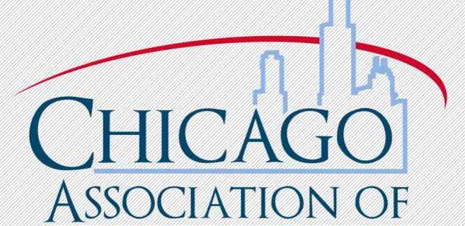
The CALL Board would like to share the findings of the membership survey that went out this summer. If there are any questions or comments about it, please forward them to Julie Pabarja, CALL President 2015-2016.

Executive Summary
A survey was sent out to the CALL membership on June 16, 2015, and stayed open until June 30, 2015. The survey was seeking feedback on the value that CALL brings to them.
There were 78 respondents to the survey. 57% of the respondents have been a CALL member for more than 10 years and 27% have been a CALL member for 5 years or less. 90% of the respondents are active members. 53% work at a law firm/corporate/special institution, 28% work at a law school and 6% work at the courts-federal/state/county.
Members were asked to identify the most valuable benefits that CALL offers. The top benefits were connecting with colleagues, education, local job postings, and the business meetings.
Networking opportunities, the network of professionals, sharing resources, and the education that CALL offers are all the things that members liked best about CALL.
Members commented on areas that CALL needed to improve. These areas included:
- More collaboration, education, and networking initiatives
- Reach out to paraprofessionals
- Be more inclusive/welcoming to new members
- Use technology to enable members to participate more
- More access for those who live outside of the city
- Connect more with students
- More mentorship and developing younger members

The Board will work with the committees to come up with ways to address these issues.
Half of our members do not follow CALL on social media. 30% follow CALL’s Facebook Page, 27% are part of CALL’s LinkedIn, and 24% follow CALL on Twitter. The Board and Committee Chairs are going to identify ways to increase our members’ participation with CALL’s social media. The Public Relations Committee will be offering education opportunities on how to use social media.
Members shared how they received information on CALL news and events. 93% rely on the CALL listserv for their information. 55% go to the CALL website and 48% get their news from the CALL Bulletin.
Members will share CALL news with their work colleagues, colleagues at other institutions and on social media.
Most of the members read the CALL Bulletin. There were comments about the new format. Members are reminded that there is a link to a pdf of the current issue that you can access.

There were lots of good topics suggested to feature in the CALL Bulletin. These topics were shared with the CALL Bulletin Co-Editors.

A good majority of the group participates in the in-kind donations and the monetary collections for the charities features at the business meetings. Members did not seem interested in participating in charity events as part of a CALL team. The list of suggested charities were shared with the Community Service Committee Co-Chairs.
72% of the members said they would attend educational programs either in person or as a webinar. The suggested topics for educational programs have been shared with the Continuing Education Committee Co-Chairs.
72% did not attend a CALL meetup last year. Many of the comments indicated that members would attend opportunities to connect with colleagues but their time is limited.
Many members are looking for events to happen after work and during lunch hour.
The Board is grateful for the thoughtful responses and comments. The Board and Committee Chairs will take all of them into consideration as we plan out the year.

AALL2GO PICK OF THE MONTH–SURVEYS: WHEN TO USE THEM AND WHY
DEBBIE GINSBERG
In the webinar Surveys: When to Use Them and Why, Debbie Ginsberg, Educational Technology Librarian at Illinois Institute of Technology Chicago-Kent College of Law, shares insights and best practices regarding creating and distributing surveys. She proposes the following steps for seeing a survey through from its creation to its distribution and review: plan, draft, test edit, distribute, analyze, and report. Also helpful is her evaluation of three popular survey tools: Qualtrics, Survey Monkey, and Google Forms.

Find this and many more archived continuing education programs on AALLNET.

LAW FIRM LIBRARIAN CURRENT AWARENESS RESOURCES

LINDSEY ANN CARPINO

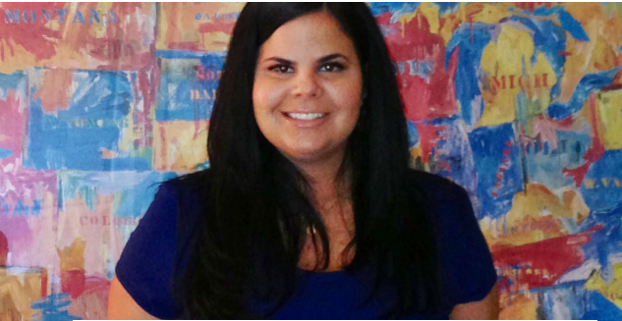

My colleagues and I have been taking turns leading our weekly Reference meetings. For my colleague, Britnee Cole’s meeting, she discussed all of the professional current awareness resources we use as law firm librarians. As we all know, we are inundated with news alerts, feeds, tweets, blogs, listservs, emails, newsletters and more. But where do we start? Many of us use news aggregators such as Manzama, Zite, FlipBoard, Feedly or Pulse to keep organized.

What are the professional current awareness resources we are using?

- CALL Bulletin of course!
- CALL Blog
- AALL Spectrum Blog
- AALL Member Communities
- Private Law Librarians & Information Professionals PLLIP-SIS
- Law-Lib
- SLA Divisions
- 3 Geeks and a Law Blog
- Dewy B Strategic
- In Custodia Legis: Law Librarians of Congress
- PinHawk Librarian News Digest

Legal News
- Above the Law
- American Lawyer
- BNA Big Law Business
- Law360 Legal Industry
- Practical Law Weekly Update
- Wall Street Journal Blog

Legal Technology
- Legal Technology Blog
- Legal Tech Newsletter
- LexisNexis Business of Law Blog

2015 AALL HACKATHON

TREZ DRAKE

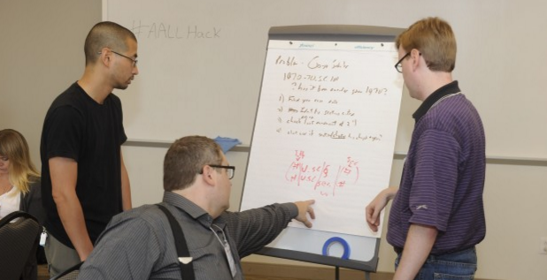

This year at the 2015 Annual Meeting, I attended the AALL Hackathon: Connecting Legal Information workshop. This second annual event was held on Saturday, July 18 from 7:30 a.m.-4:30 p.m. at Peirce College in Philadelphia. According to the organizers, the purpose was to “bring together those with knowledge of available resources and needs, like law librarians, with those who have the technological know-how to build mobile and web applications to use those resources and meet those needs.”
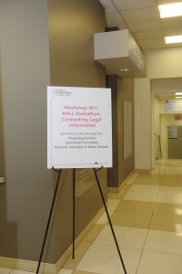
Courtesy of the American Association of Law Libraries/Brant Bender Photography

I participated in this workshop on a lark. I am not a hacker, a coder, or technology person. I own and use technology, but I also still think fondly of the good old days when we had to wedge half a clothespin in the tape player to make the 8-track play properly. I happily have friends who are technology fiends, and I am quite comfortable with association, but that is intentionally not my area of expertise. So, attending a Hackathon was not the most obvious choice for me.

The instructions for this Hackathon were to bring a computer and an idea of legal or government information that could be made more accessible for users. And, together with a programmer, we would begin to build a useful and free resource. Examples of such projects are GovTrack.us and the creation of a PROXYsearch script that transformed the South Carolina Judicial Opinions webpage into a site with an integrated search interface and improved access to the judicial opinions. This script won the AALL Hackathon prize in 2014.

I signed up for the Hackathon because I wanted to be exposed to the process of creating a legal portal from beginning to end. I did not have any ideas, and didn’t try to formulate any plans. I fully intended to be a lurker at the Hackathon. However, I was pleasantly surprised to find that many of the attendees also did not have ideas. Somehow, we were able to develop and begin executing a plan.

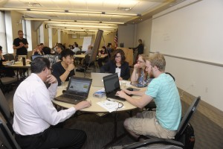
Courtesy of the American Association of Law Libraries/Brant Bender Photography

I got the chance to work with four librarians and a programmer to brainstorm an idea for a webpage that performed a 50-state survey to determine whether a particular topic might be trending in the news; the page would have had a “heat map” that showed how “hot” the topic is across the country. We envisioned this tool as a pre-research device to help students and other researchers determine whether a certain research topic might be viable before spending time and energy researching statutes and cases.

As a team, we made decisions about what the page should do, how it should look, and what functions should occur in the fore- and background of the site. Based on those ideas, our programmer began to build our page and search engine from scratch. We were euphoric, already planning how we would spend our $250 prize (yes, there was money to be won)!

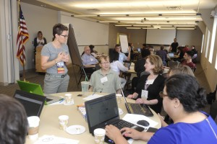
Courtesy of the American Association of Law Libraries/Brant Bender Photography

Our joy ended when someone ran a web search and discovered that Google Trends does what we’d hoped our search engine would do, and so much more. Needless to say, we were disappointed. The leaders of the event tried to encourage us with the fact that our idea was viable, even though Google got to it first. We even played around with a few modifications, but eventually we gave up and left the Hackathon early.

This Hackathon was a good introduction to partnering with a team, including a programmer, to build something new. We didn’t get the results that we had hoped. We did not create an app or a webpage. There was nothing that I could list with pride on my resume. But, I learned quite a bit.

Every time I search the web or use a database and find something that could work better, I have a potential idea for a hack. And, I don’t need to know how to design the patch or create the webpage myself. I just need to be able to communicate the problem to my programmer or technology colleague and brainstorm how to make said improvements. I learned that teamwork can be relaxed, fun, and productive. And, as every good research librarian should remember, I was reminded to always run a preemption check.
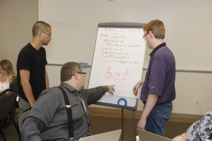
Courtesy of the American Association of Law Libraries/Brant Bender Photography

I’m not sure if I’ll attend the Hackathon in Chicago. Devoting an entire day to this project is a lot to ask. But, I will keep a running list of changes and improvements that I’d like see and think about whether there is something that can be built to make legal information easier to access.

If you are even remotely interested in what was accomplished at the Hackathon in the past years, I encourage you to sign up and attend. Lurkers are definitely welcome. And, you might surprise yourself by participating on the winning team.

SUMMER INSTITUTE OF THE ASSOCIATION FOR COLLABORATIVE LEADERSHIP

JOANN HOUNSHELL

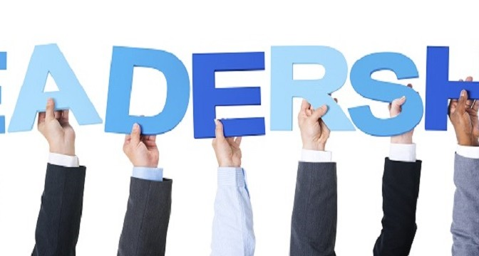

Boston, Massachusetts is like Chicago in that, no matter how many times you visit, there is always something new to discover, something new to learn. I had the opportunity, thanks to a CALL travel grant, to learn something new by attending the Summer Institute of the Association for Collaborative Leadership (ACL) in Boston. The purpose of the ACL is to promote and support higher education partnerships through professional development, resource sharing, and program enhancement. Each summer the ACL holds The Institute on Collaboration in Higher Education. The Institute provides a unique opportunity to learn from leaders in consortia, and other collaboration-based non-profit organizations.

In June, the ACL held the fifth Institute, which consisted of a three-day curriculum taught in an interactive workshop format. The class was made up of 21 students and 6 faculty. Of the 21 students, 4 were law librarians, and 2 members of the faculty held masters in library and information science! The takeaway here is that librarians naturally gravitate toward collaboration.
The Institute required full participation. The students and faculty had breakfast, lunch, and dinner together. This allowed us to continue conversations begun in the classroom. Students had reading assignments prior to the Institute, and homework each evening. On the last day, each student gave a five-minute presentation on a capstone project that they hope to develop. Think graduate school on steroids.
By the end of the Institute, participants left with a clear(er) understanding of the role, and needs of an organization as partners in collaborations. We also left with specific skills in planning, budgeting, leading inter-institutional groups, developing programs, and cultivating funding resources.
Over the course of the three days, I was asked to describe law librarianship and libraries. Why are law libraries important? What are the challenges and opportunities facing the legal industry? Talking to non-librarians about law libraries required an adjustment in delivery. No jargon allowed. I started looking at law libraries from the other side of the table, something I had not done in a long time.
I came away from the Institute on Collaboration in Higher Education curious about what collaborative opportunities there might be in CALL. Of personal interest to me is the preservation of born digital legal information. As law librarians, we play a critical role in developing strategies for the preservation of born digital information. Local government born digital information is at the most risk of being lost. County and city agencies rarely understand the historical need for preserving regulations that are only in electronic format. Law librarians understand!
Preservation of born digital legal information can be expensive and labor intensive projects. The most obvious solution to these issues is to seek opportunities for collaboration, which would allow for the sharing of costs, resources, and expertise. But how do we get this message up the ladder in our organizations, and get the support for a project?
I centered my capstone idea on developing a communication plan that could be used by law library directors to help educate law school deans, law firm managing partners, or chief judges on the importance of preserving born digital legal information. Librarians are already on board regarding the need and urgency of preserving legal information. However, sustainable collaborative projects have to have the support from the dean and C-suites, as well as the judge’s chambers. My plan is test drive my capstone project among my colleagues in CALL and AALL to create a communication toolkit that can be used by any legal organization.
I am grateful to CALL for awarding me a travel grant to continue my professional development. Attending the ACL Summer Institute has given me an opportunity to explore new ideas that I want to bring back to CALL.

MAALL ANNUAL MEETING 2015
LINDSEY ANN CARPINO

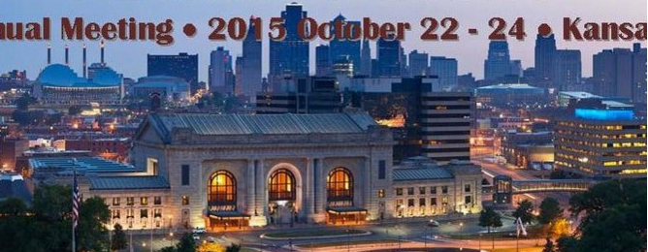
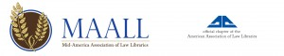
The Mid-America Association of Law Libraries (MAALL) is having their Annual Conference October 22 – 24, 2015 in Kansas City, MO. The theme is “Everything’s Up to Date in Kansas City!” A preliminary program schedule is available. [PDF]. There is also amobile-friendly version of the program. You can stay in touch with MAALL on Twitter: @MAALLibraries. The conference hashtag is #MAALL15.

AALL 2016 LOCAL ARRANGEMENTS COMMITTEE
MARIBEL NASH

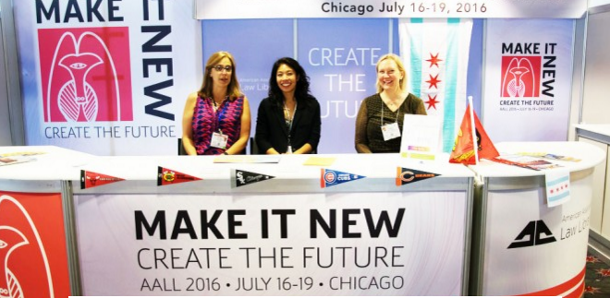

CALL’s AALL 2016 Booth at AALL 2015 in Philadelphia
Many thanks to everyone who helped to promote the 2016 AALL Annual Meeting in Philly!
AALL is so excited to host the first Annual Meeting and Conference in Chicago since 1987, the year:
- The Bangles had a #1 hit with Walk Like an Egyptian
- Paul Newman won the Best Actor Oscar for The Color of Money
- Future Blackhawk Captain Jonathan Toews was just a twinkle in his mother’s eye

CALL members stepped up to promote our great city throughout the conference!

Special thanks to CALL members who volunteered at the Local Arrangements Booth: Annie Mentkowski, Ben Brighoff, Bridget MacMillan, Carolyn Hersch, Claire Toomey Durkin, Deborah Ginsberg, Debra Denslaw, Diana Koppang, Emily Barney, Erin Schlicht, Jean Wenger, Jesse Bowman, JoAnn Hounshell, Joe Mitzenmacher, John Klasey, Julie Pabarja, Julie Stauffer, Kara Dunn, Kara Young, Lucy Robbins, Margaret Schilt, Patricia Sayre-McCoy, Sally Holterhoff, Scott Vanderlin, Stacia Stein, Todd Ito, Tom Gaylord, and Trezlen Drake.

We were so lucky to have such a high number of volunteers that everyone was able to participate by committing a small amount of time. We’re looking forward to working with CALL throughout the year as we prepare to Make It New & Create the Future in Chicago in July 2016!

The 2016 AALL Local Arrangements Committee:
- Megan Butman and Maribel Nash, Co-Chairs

Sub-Committees:
- Jamie Sommer and Lucy Robbins, Hospitality
- Annie Mentkowski and Joe Mitzenmacher, Registration
- Jesse Bowman, Website and Publicity
- Tom Gaylord and Scott Vanderlin, Library Tours and Excursions
- Vanessa Nelson Meihaus, Exhibits
- Claire Toomey Durkin and Carolyn Hersch, Volunteers
- Beth Mrkvicka, Restaurant Guide

AALL 2015 CONFERENCE SESSIONS AVAILABLE ON AALL2GO
LINDSEY ANN CARPINO
Were you unable to attend this year’s AALL Annual Meeting & Conference in Philadelphia? No need to worry! Not only did the CALL Bulletin cover the conference through our AALL Summer Supplement, AALL has also placed session recordings on AALL2go. Best of all, these are free! You can access these here.

2015 AALL BUSINESS SKILLS CLINIC
LINDSEY ANN CARPINO
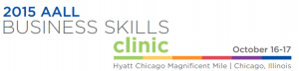

The AALL Business Skills Clinic was held on October 16-17, 2015 at the Hyatt Chicago Magnificent Mile located at 633 N. St. Clair Street Chicago, IL, 60611.

AALL Business Skills Clinic describes itself as:

“The AALL Business Skills Clinic will provide legal information professionals the opportunity to learn core business skills to make effective contributions within teams and the larger organization. Learn from experts in the field who will provide you with strategies to apply immediately. Collaborate with colleagues in a small group setting while gaining essential skills, tools and techniques to equip you for the road ahead.”
The following topics were covered:

- Managerial Finance
- Human Resources
- Marketing and Communications
- Performance Measures
- Negotiations
- Strategic Planning

You can find more information including speakers here.

2015-2016 CALL MEETING SCHEDULE
JULIE PABARJA

Business Meetings
Business Meetings and Educational Events Policies

2015
- September 17, 2015 (Thursday)
- November 19, 2015 (Thursday)

2016
- February 25, 2016 (Thursday)
- May 12, 2016 (Thursday)

Executive Board Meetings
Starting at 8:45am
For 2015-2016 the Board will meet the second Tuesday of every month. Specific dates are:
2015
- June 9 (Tuesday)
- August 4 (Tuesday)
- September 8 (Tuesday)
- October 13 (Tuesday)
- November 10 (Tuesday)
- December 8 (Tuesday)

2016
- January 12 (Tuesday)
- February 9 (Tuesday)
- March 8 (Tuesday)
- April 12 (Tuesday)
- May 10 (Tuesday)

Details will be posted as they become available.
Dates subject to change.
CALL would like to thank all of the speakers and meeting sponsors at this year’s business meetings.

ABOUT
The CALL Bulletin, the official publication of the Chicago Association of Law Libraries (CALL), is published four times a year and is provided to active members as a benefit of membership.

It is available at:

http://bulletin.chicagolawlib.org/
http://new.chicagolawlib.org/news-and-events/call-bulletin/

CALL does not assume any responsibility for the statements advanced by the contributors to the CALL Bulletin, nor do the views expressed in the CALL Bulletin necessarily represent the views of CALL or its members.

Contributions to the CALL Bulletin are always welcome. Please be advised that contributions submitted for publication are subject to editorial review. The Bulletin editors have the discretion to decline to publish articles.

Editors:
Direct questions, articles, or other items of interest to the co-editors:
Lyonette Louis-Jacques
University of Chicago D’Angelo Law Library
1121 E. 60th St., Chicago, IL, 60637
Phone: 773-702-9612 Fax: 773-702-2889
llou@uchicago.edu

Lindsey Ann Carpino
Sidley Austin LLP
One South Dearborn
Chicago, IL. 60603
Phone: 312-456-5318
lcarpino@sidley.com

Scott Vanderlin
IIT Chicago-Kent College of Law Library
565 W. Adams St., Chicago, IL 60661
Phone: 312-906-5676 Fax: 312-906-5679
svanderlin@kentlaw.iit.edu

Deadlines for submitting articles:
Issue | Deadline
Fall | August 1
Winter | November 1
Spring | February 1
Summer | May 1

CALL Membership:
For CALL membership information, please contact:
Therese Clarke Arado
David C. Shapiro Memorial Law Library
Northern Illinois University
DeKalb, IL 60115
Phone: 815-753-9497
tclarke@niu.edu

Reprinting & Republishing:
Anyone who wishes to reprint or republish any part of the CALL Bulletin must have prior written approval from the CALL Bulletin editors.

Anyone who wishes to reprint or republish an entire article from the CALL Bulletin also must have prior written approval from the author of the article.

If the reprinted or republished material includes the CALL logo or is intended for commercial purposes, then additional prior written approval must be obtained from the CALL Executive Board.

